Project 3

CS 623

Retirement Planning Calculator

Prepared by
Ahmed M Khan

Screen Outputs:

Main Window

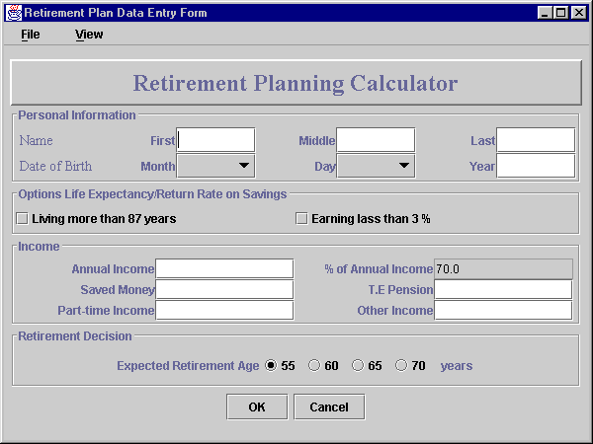

This frame is designed using GridBagLayout having six Panels. One contains heading, four for information handling and one for buttons.

Each Information Panel is designed using GridLayout.

Mandatory fields to enter:
- First Name and Last Name
- Date of Birth
- Annual Income
- Expected Retirement Age

The program if left blank by the user handles rest of the fields. Default value of ‘percentage of annual income’ is 70.0 and ‘expected retirement age’ is 55. Other fields have 0 values.

User can view the reports in two formats:
- Summary Report - displayed using dialog box
- Detailed Report – displayed using new frame

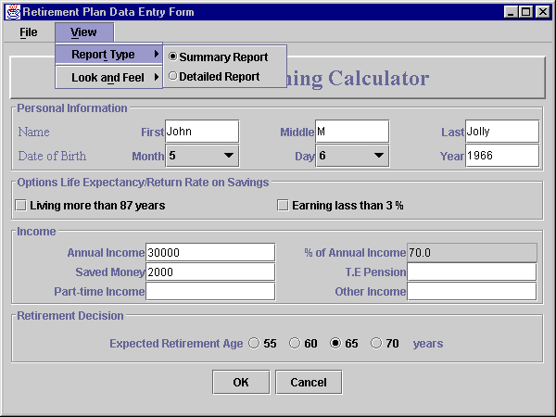

Note:
Social Security for married couples is not included in this program.

Summary report is selected by default. User can toggle between them.

When user supply all required fields and clicks OK button, the following dialog box appears,

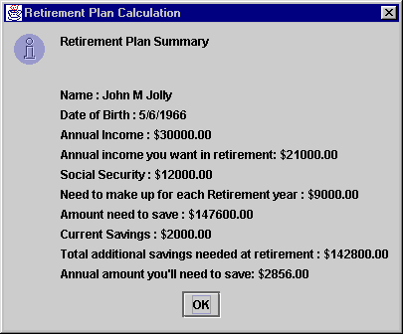

When user anticipate living longer than 87 years or earning less than a 3% real rate of return on his/her savings, s/he can select the options check box and increase the percentage of annual gross income. After selecting one of the options, % Annual Income text field becomes editable.

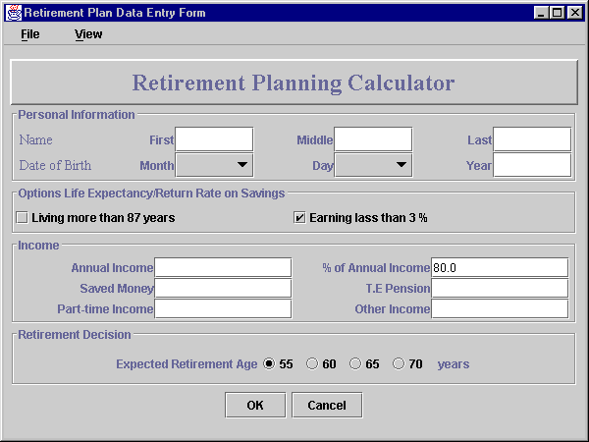

User can then change the percentage value.

When user selects the detail report option and clicks after supplying required fields, following screen appears;

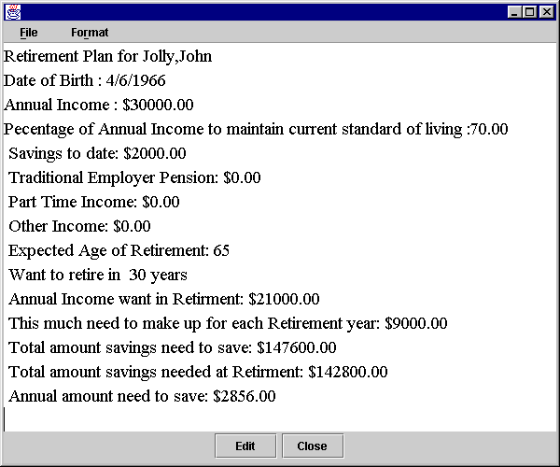

This report is displayed on text area. After displaying it, user/operator can change the contents and add remarks. This way user can print the copy with remarks. Printing facility is not provided in this program.

If user clicks Cancel and
- without viewing any reports, system exits without displaying anything.
- viewing one or more reports and summary report is selected, system displays the last records in a dialog box and exits.
- viewing reports while detail report is selected, system exits without displaying anything.

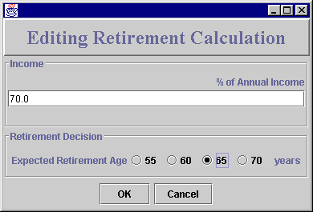

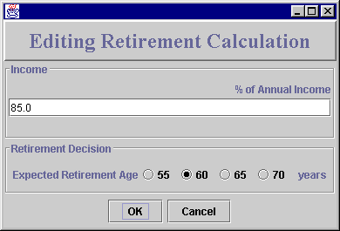

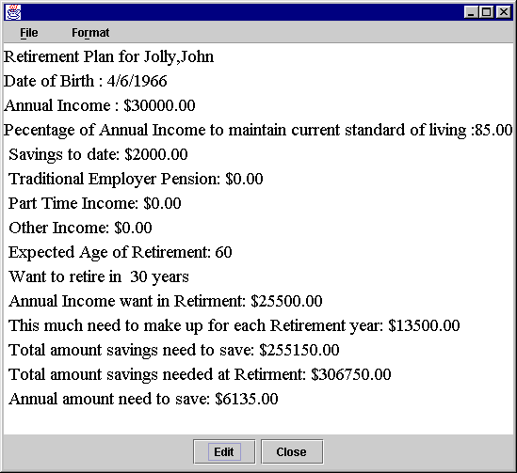

Error handling
If user clicks OK without entering anything, system displays messages in following fashion.

- If user does not enter name, system displays following error message
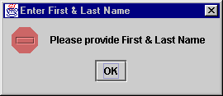

- if user does not enter annual income or retirement age, systems displays

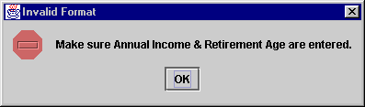

- if user enters birth year later than 1980 or before 1930, or does not enter anything in dates, system displays

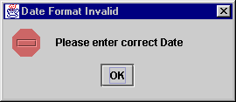

Additional Features

Look and Feel
Some users do not like Metal or Motif frames. They can select windows frame. Or in any order user prefers. These options are supplied under views menu. These options change the entire look and feel of the window.

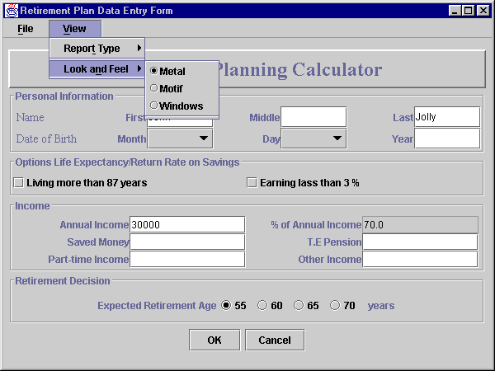

Following look and feel options are provided:
- Metal (default)
- Motif
- Windows

When user selects Motif, screen changes as follows
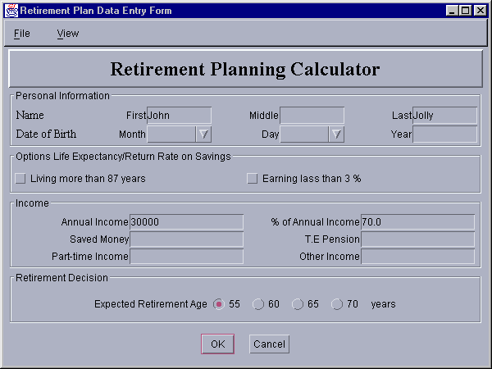
When user selects Windows, screen changes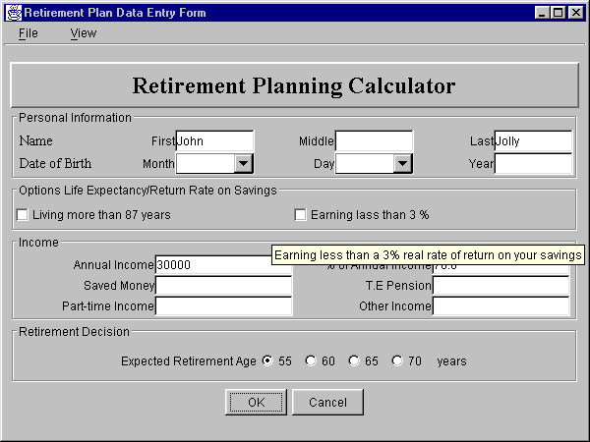

Tool Tip feature is also provided for few labels like in options that needs little more explanation.
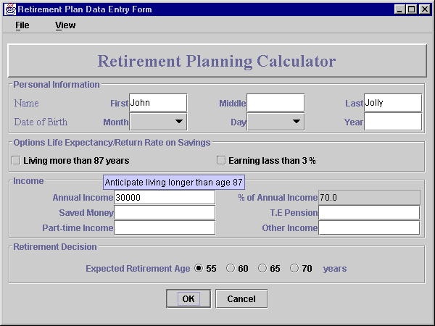

If user needs more explanation about this calculator, s/he can go to the web-site mentioned in About option under File.

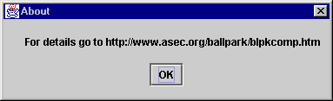

User can also exits from the system, by using Exit option under File.

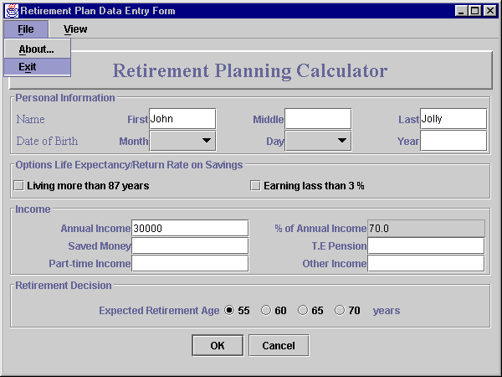

Detail Report additional features
User can change the color and fonts of the output in the text area.
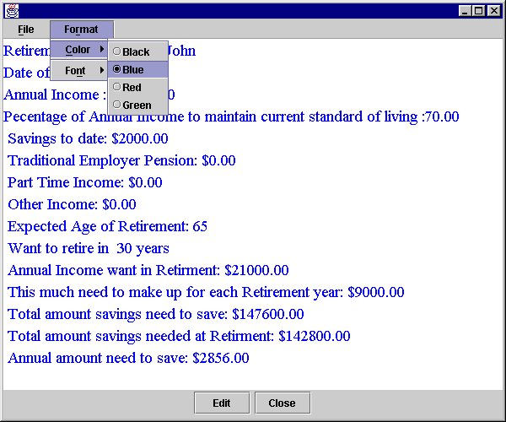

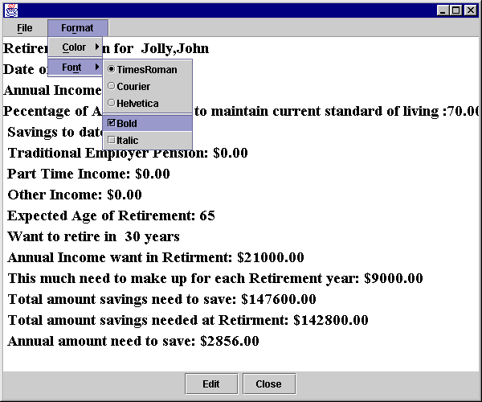
When user exits, program hides the detail report frame.

Screen Output of Earlier Version using only GridLayout:
Main Window:

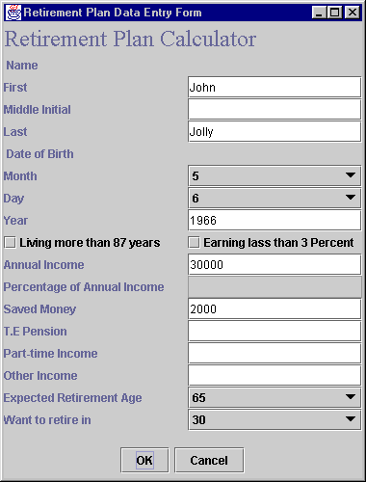

This window is not much user friendly. Its design is flat using BorderLayout directions. It provides the same background features as the newer version except;
user needs to provide the Date of birth, Retirement age and period before retiring.

This feature is automatically handled by the newer version that uses system date to calculate pre-retirement period.

When user enters the required fields, systems displays the report in a dialog box.

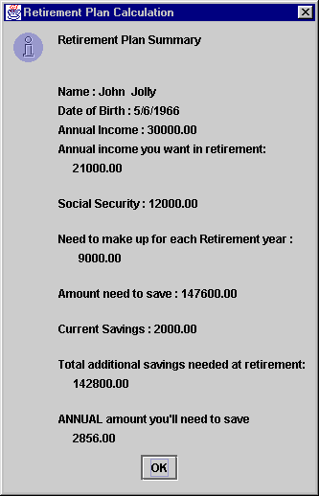

Program Listing

- UserWindow.java
- RetPlan.java
- Report.java
- Date.java
- DateFormatException.java
- NeedNameException.java

Screen Output &Program Listing

- UserWindow.java
- All other file are almost same

(Earlier Version using GridLayout only)

References

Java How to Program
3rd edition

Deitel & Deitel
Prentice Hall 1999

Up to Speed with Swing
2nd edition
Steven Gutz
Manning 2000

